CREATING YOUR NETVIBES DASHBOARD

STEP 1.
Follow the link to the Netvibes homepage www.netvibes.com
STEP 2.
Click on the green Get Started button on the left side of the screen.
For the free option, click on ‘Go basic’
Type in your topic of interest or pick a popular dashboard below, then click ‘Dashboard it’
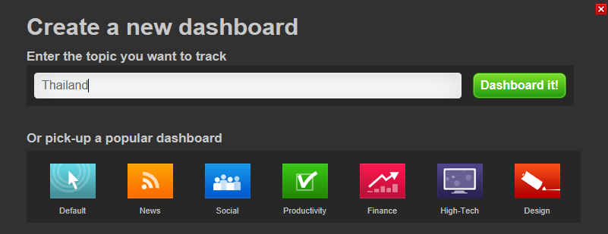
Wait while Netvibes creates your site!

STEP 3.
Now it’s time to personalise your dashboard!
Personalise with a pic!
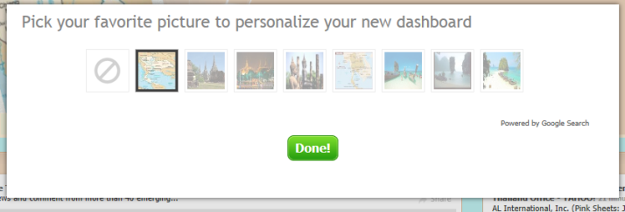
Add content!
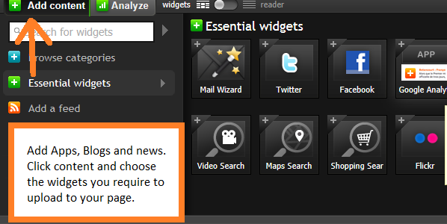

Modify your apps and tabs!
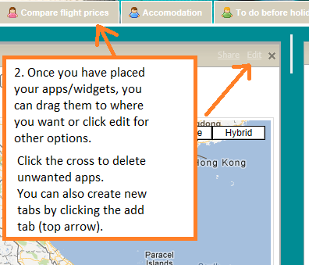
Make it public!
To do so: click on dashboards in the top right hand corner, then Manage, click to enable.
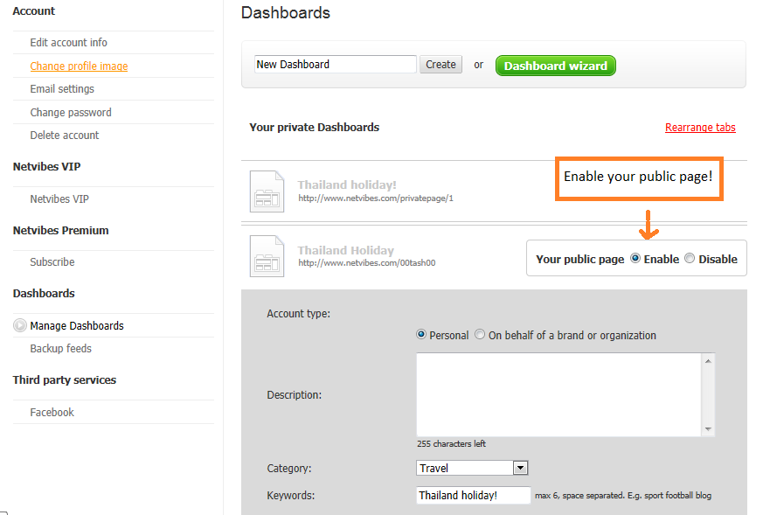
Sign up to save!
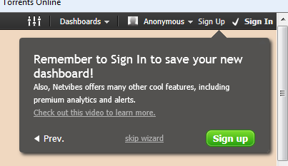

STEP 4.
Interacting with friends and followers.
Click on your user name (In my case the yellow highlighted 00tash00), then click on contacts. Here you can invite friends to view your page. You can also keep an eye on your followers and block anyone you don’t want viewing your page.
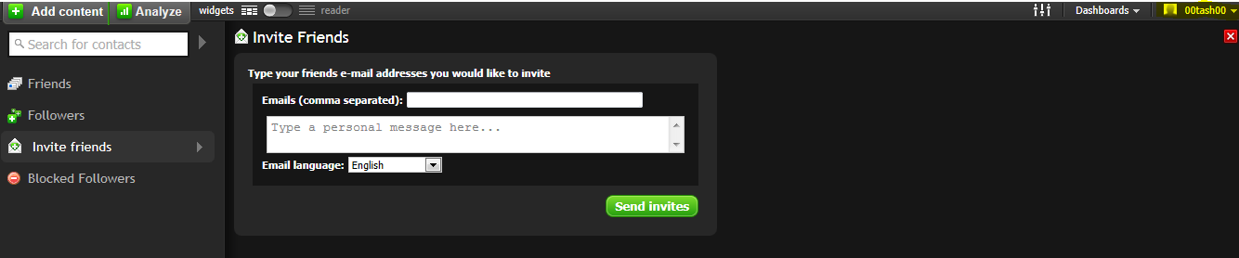
There are loads of ways to interact on Netvibes. Below I've captured a few of the ones I’m using on my page. To find these apps, click on the Add content button and type in ‘social’ ‘chat’ ‘wall’ or any particular social account you may have. In my case, I have a Google, Skype and LiveMessenger account. I’ve loaded them all onto my page so I can interact with all my friends no matter what social account they have.
Make sure you’re signed into your accounts on your wall so people can contact you.
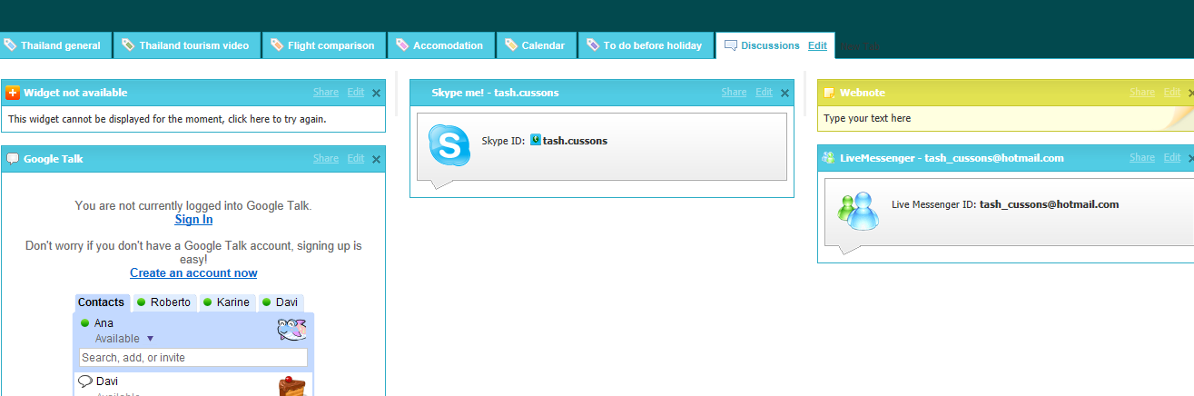

Now enjoy your new Netvibes site!

